**5.2 Building Continuous Integration Pipelines In Jenkins**

This section will guide you to:

* Build Continuous Integration Pipelines in jenkins

This lab has two sub-sections, namely:

5.2.1 Building a Maven project

5.2.2 Creating a Pipeline to build the project

**Step 5.2.1:** Building a Maven project

* Login to your **Github** account.
* Click on the plus icon next to the profile picture and select ***New repository*** from the drop-down menu.

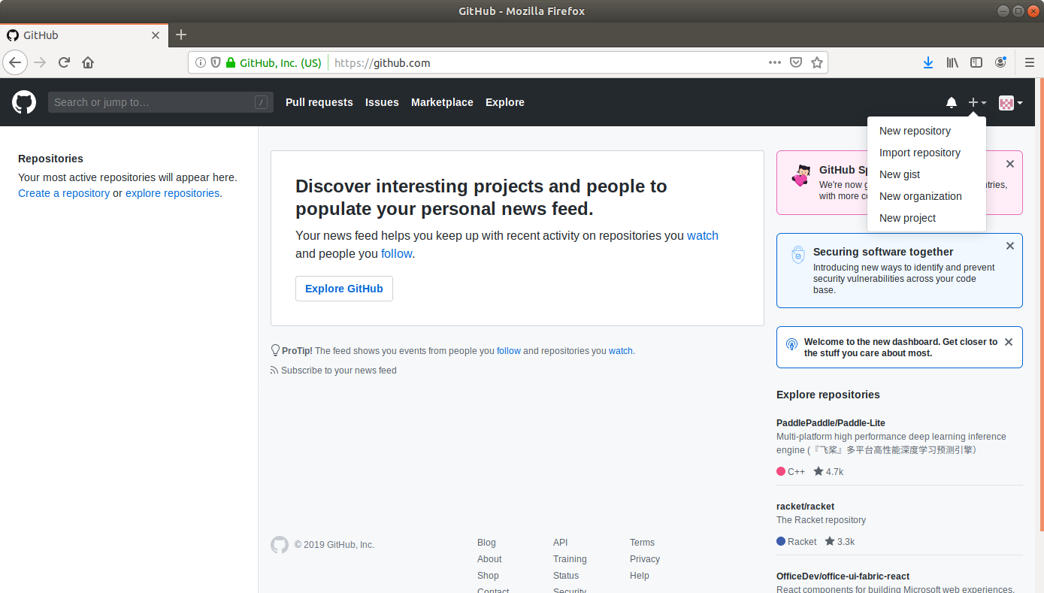

* Fill the required fields in the create repository form.
* Click on the **Create Repository** button.
* Click on the **Clone or download** button and copy the URL.
* Go to ​start.​spring.​io/​

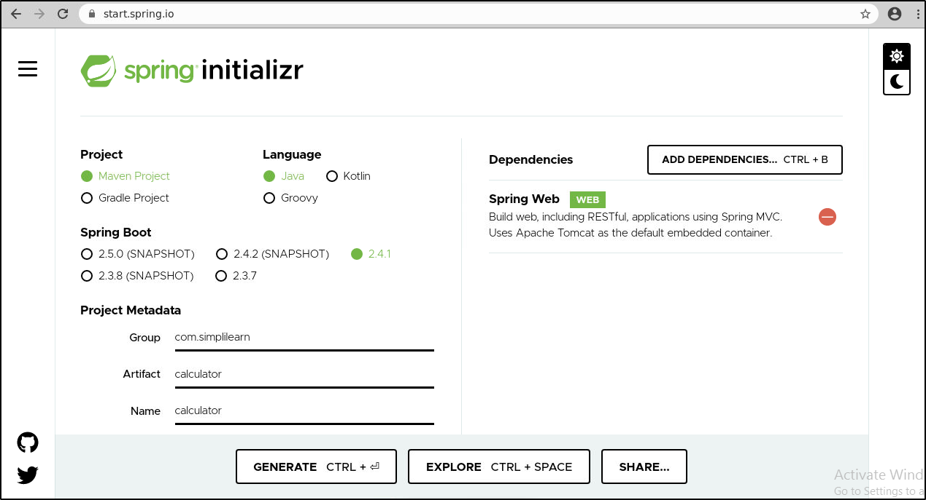

* Select **Maven** as the project type.
* Fill Group and Artifact with appropriate values. For example,***com.simplilearn*** and ***Calculator.***
* Add **Web** (Spring Web) to Dependencies.
* Select Packaging: **Jar**
* Select Java: **8**
* Click on **Generate Project.**
* The generated skeleton project should be downloaded as a **zip** file.
* Open the terminal and navigate to an appropriate location.
* Run **git clone [URL]** to clone the repository.
* **Unzip** the downloaded spring boot project to the cloned repository.  
  (cd Downloads  
  unzip Calculator.zip)
* Copy the contents of Calculator folder present in downloads and paste it into your repository folder)
* Commit the changes to the remote SCM.
* Run **git add .**
* Run **git commit -m “Add logic and test”**
* Run **git push -u origin master**

**Step 5.2.2:** Creating a Pipeline

* Go to Jenkins **dashboard**.
* Click on ***New Item***.
* Enter a **name** for your build job.
* Select **Pipeline**as the build job type.

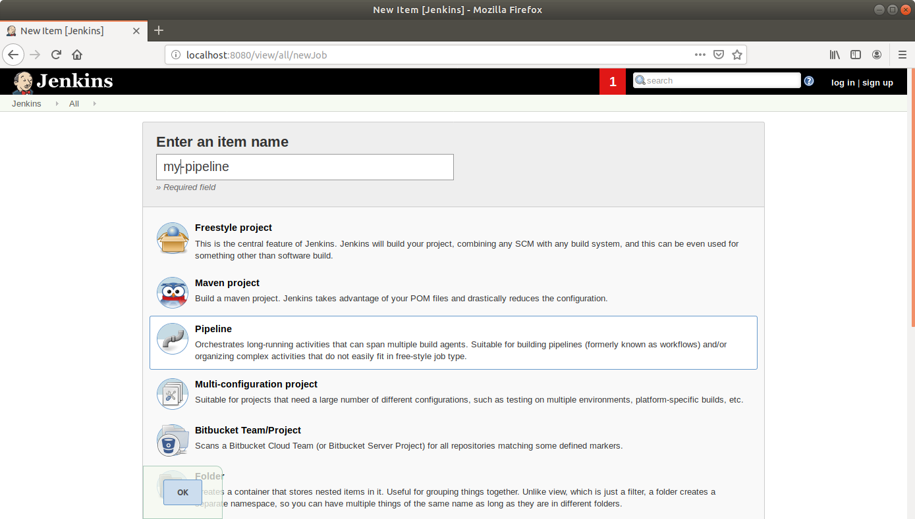

* Click **OK**.
* Scroll down to the Pipeline section and enter the script below:

**pipeline {**

**agent any**

**tools {**

**maven 'my_mvn'**

**}**

**stages {**

**stage("Checkout") {**

**steps {**

**git url: '<YourGithubRepoURL>'**

**}**

**}**

**stage('Build') {**

**steps {**

**sh "mvn compile"**

**}**

**}**

**stage("Unit test") {**

**steps {**

**sh "mvn test"**

**}**

**}**

**}**

**}**

* Click **Save**.

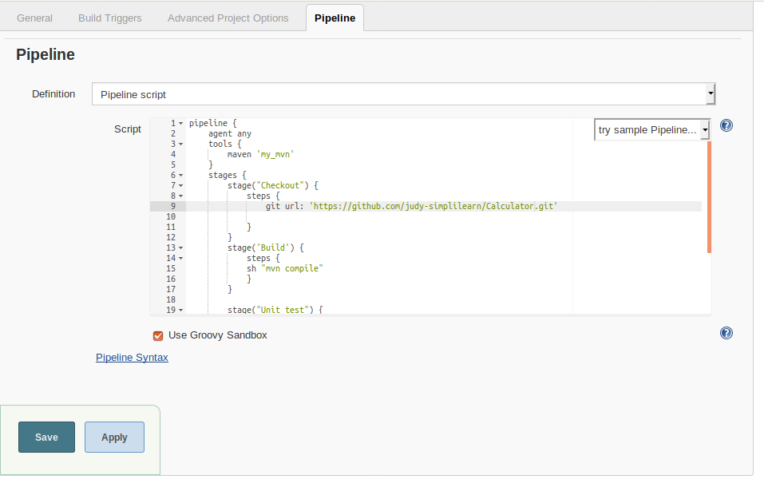

* Click ***Build Now*** in the project window to make sure that the build works. Jenkins will now build your project.
* Click on the ***Build History***to view the build results.
* Click on the ***Logs***to view the build logs in each stage.

